Audio Editor User Documentation

Upon starting the application, the form pictured below will load.
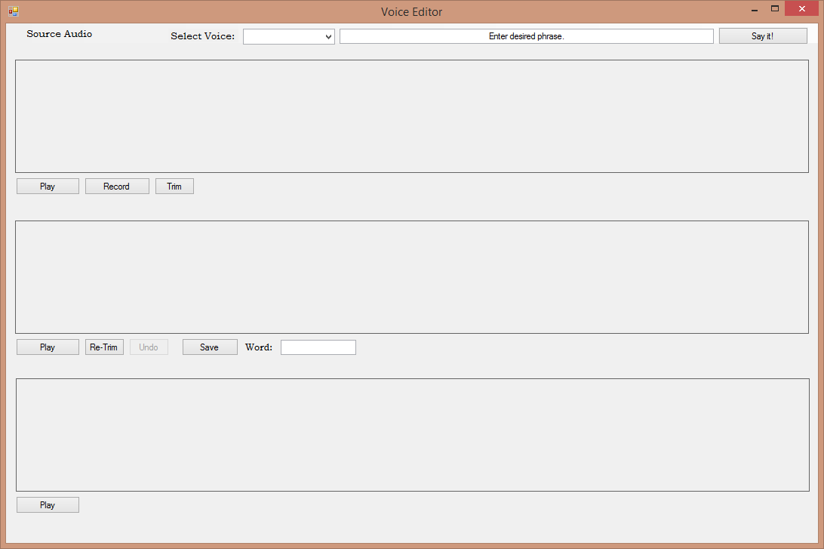
This form contains all the necessary tools for loading / recording audio, cutting the audio clips into manageable pieces, and reconstructing the audio into new phrases.
From the top, the user may elect to open an existing audio file for cutting clips by selecting ‘Source Audio’ -> Open. Alternatively, they may record new raw audio files by using the Record button below the top audio wave viewing box.
Important Note: If recording while running program on USB drive, the resulting audio may low quality or unusable.
Once a working wave is open or finished recording the waveform will display.
The user is free to highlight any sub-portion of the audio wave in the topmost wave viewer. Once satisfied, the user may select Trim and this will fill the middle audio wave viewing box with the selected portion of the wave.
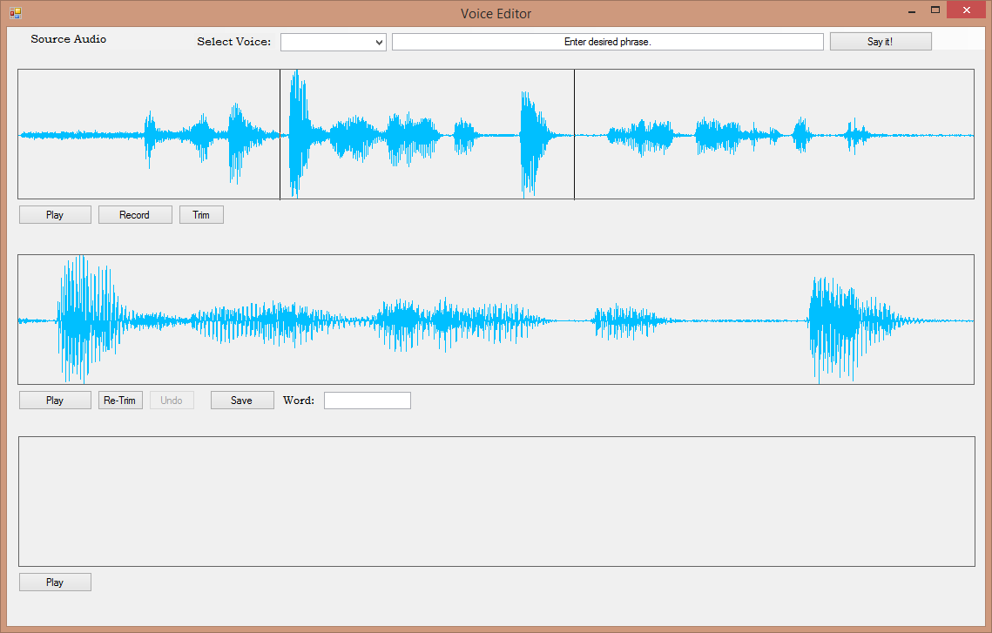
The trimmed audio wave may be overwritten or re-trimmed until a desirable / useful audio clip is isolated.
At this point, make sure to have selected whose voice the recording belongs to from the ‘Select Voice’ dropdown (or, if the voice does not exist you may elect to add it by choosing the corresponding option in the dropdown).
Once satisfied, type the word that has been isolated into the textbox below the middle audio wave viewer. The word / clip will be saved and associated with the selected voice.

Assembling New Phrases
Once a collection of audio clips is saved you may wish to re-arrange them into new phrases.
Assembling a new phrase from existing pieces is easy; simply select the proper voice from the ‘Select Voice’ dropdown box, then enter the text (with each word spelled exactly as the clip was saved). Click ‘Say it!’ and the new phrase will be constructed for you and loaded into the bottom audio wave viewer.
